1. What are three conclusions we can make about Kickstarter campaigns given the provided data?
   1. The most common project on Kickstarter is categorized as a play, approximately ⅔ of which have been successful.
   2. Projects with the greatest odds of
      1. Success are (in no particular order):
         1. Technology: hardware
         2. Publishing: podcasts, nonfiction
         3. Music: rock, pop, metal, electronic/classical
         4. Games: Tabletop
         5. Food: Small batch
         6. Film & video: Television, shorts, documentary.
      2. Failure are (in no particular order):
         1. Technology: web, gadgets
         2. Publishing: Translations, fiction, children’s books
         3. Photography: Places, people, nature
         4. Music: faith
         5. Games: Video games, mobile games
         6. Food: restaurants, food trucks
         7. Films & video: Drama, animation
   3. The only month that more projects created tend to fail rather than succeed is December.
   4. There is a linear relationship between the goal amount and likelihood of project cancelation.

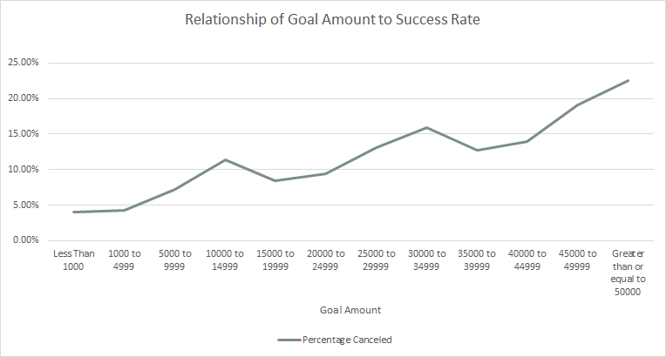

1. What are some of the limitations of this dataset?
   1. 4000 out of 425,118 (as of 11/14/18) total projects is less than one percent -- a very small subset of total projects. As a result it appears that video games, for instance, are guaranteed failure when in fact [Shenmue III](https://www.kickstarter.com/projects/ysnet/shenmue-3?ref=discovery) is one of the [most funded](https://www.kickstarter.com/discover/advanced?sort=most_funded&seed=2571651&page=1).
   2. Some projects span more than one category and/or subcategory, or might not match any existing category well.
   3. The information is restricted to Kickstarter, which has limited relevance without context of other fundraising websites and methods.
   4. Without a currency converter function, the goal and pledged amounts as currency are unrelated data points unless you filter by currency.
   5. Goal amounts can fluctuate during their campaign -- if a project meets its goal, the creator(s) may increase the amount, which leads to unreliable data in the “goal” column.
2. What are some other possible tables/graphs that we could create?

Success Variation With and Without Staff Pick Status

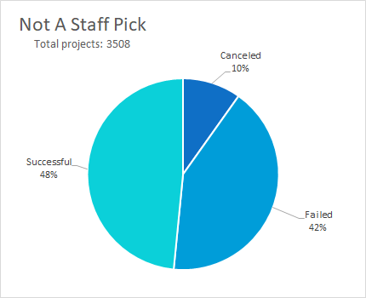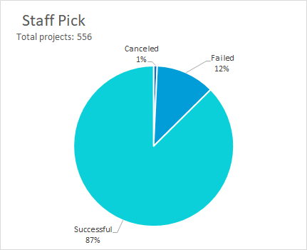

The comparison can also be shown in a single graph:

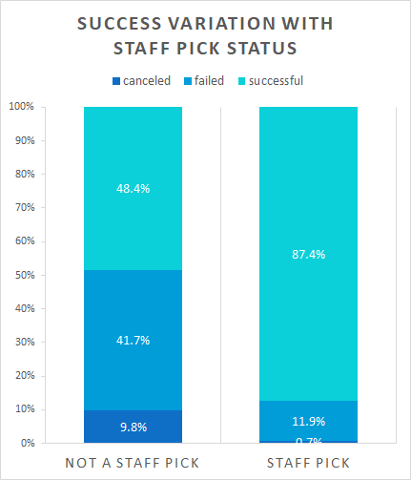

Relationship of pledged amount vs goal amount in USD, in **successful** projects, broken out by category:

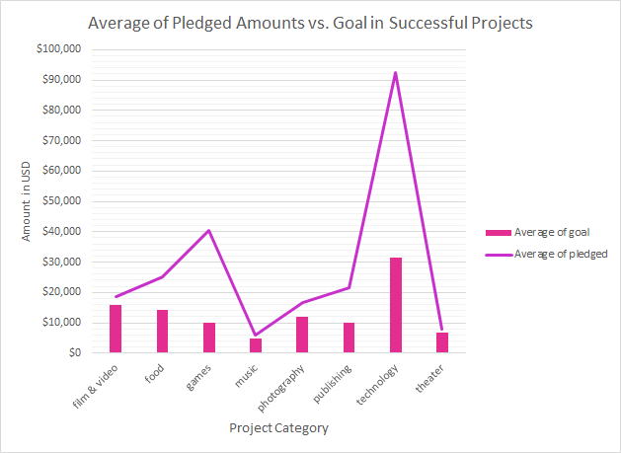

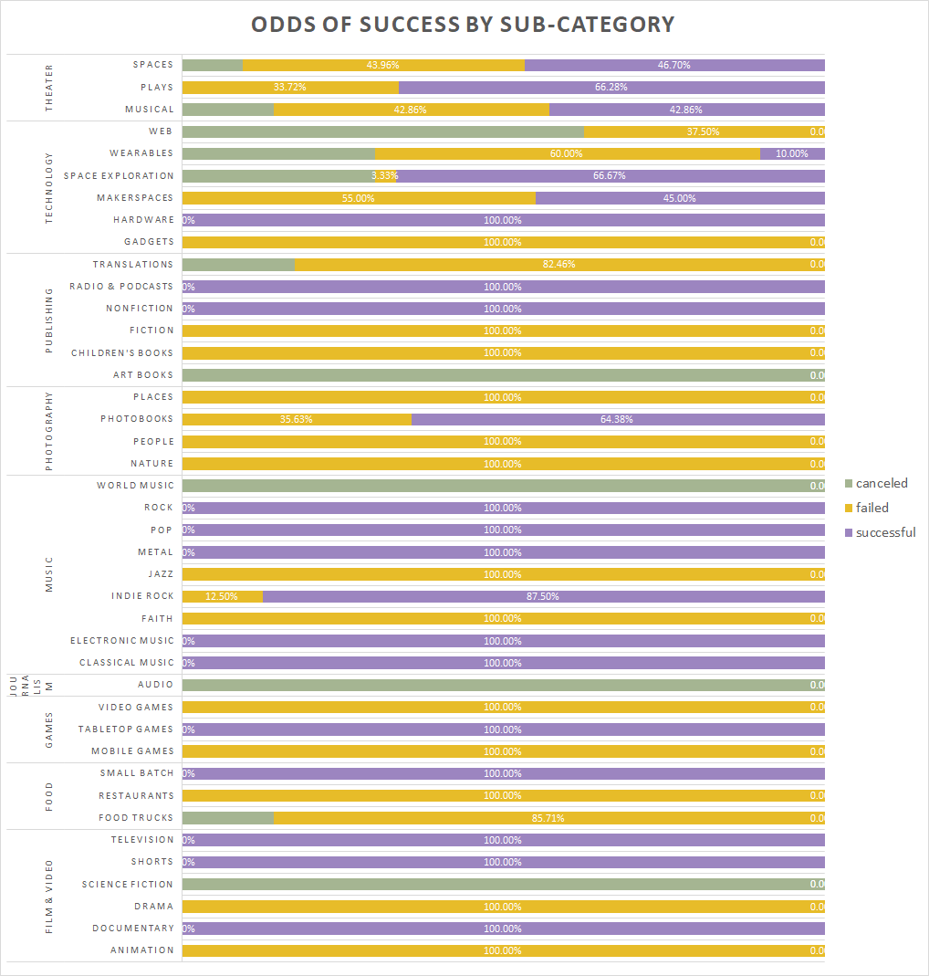

Is this one particularly useful? No. Is it neat? Yes.

